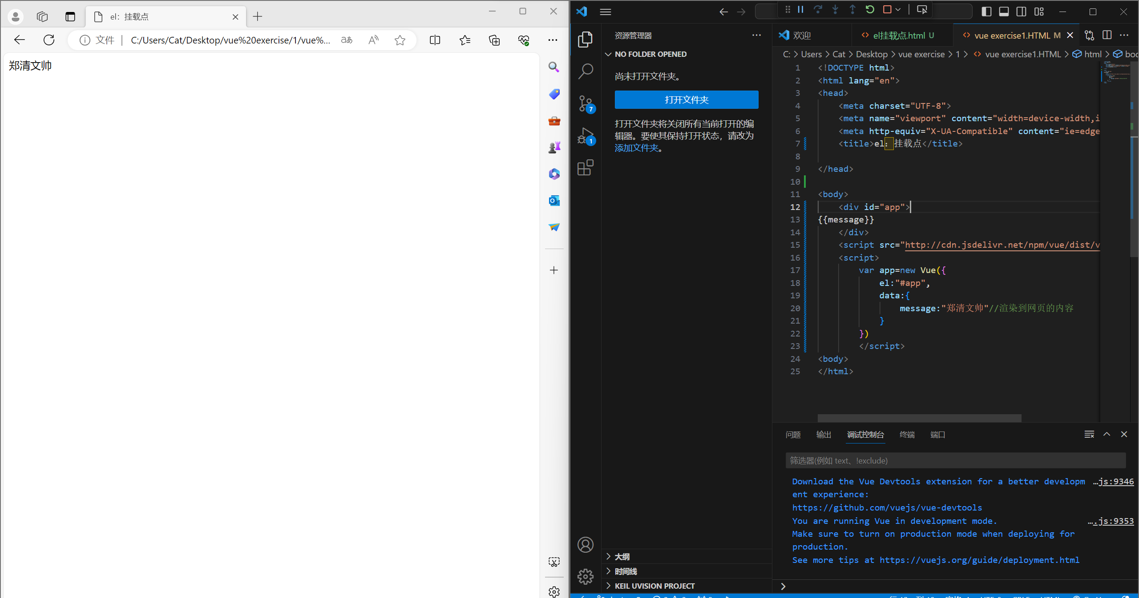

<!DOCTYPE html>

<html lang="en">

<head>

    <meta charset="UTF-8">

    <meta name="viewport" content="width=device-width,initial-scale=1.0">

    <meta http-equiv="X-UA-Compatible" content="ie=edge">

    <title>vue exercise</title>

</head>

<body>

<div id="app">

    {{message}}

    </div>

    <script src="http://cdn.jsdelivr.net/npm/vue/dist/vue.js"></script>

    <script>

        var app=new Vue({

            el:"#app",

            data:{

                message:"Hello Vue!"//渲染到网页的内容

            }

        })

        </script>

<body>

</html>